

**Kingdom of Saudi Arabia**

**Ministry of Higher Education**

**King Faisal University**

**College of Computer Sciences & Information Technology**



**Computer Organization and Architecture**

Project Document

Supervised By: **Tassadaq Nawaz**

Group members:

Mohammed Eid. 218038022

Abdullah Alhumaid.219014440

Ali Alqattan.219022038

Project idea 1

Planning 2

Design phase 3

Testing 7

Conclusion 10

## ****Project idea****

* The idea of project is to use the basic computer (MorrisMano) to get the four instructions from the user and 10 memory locations, and the program will deal with it as hexadecimal number from the user side and the program will convert it to binary then it will separate each part of it, and it should have the interface to be more usable and readable by the user
* We will start the program form the input to get the tracing

## Design phase

1- input analyzing phase

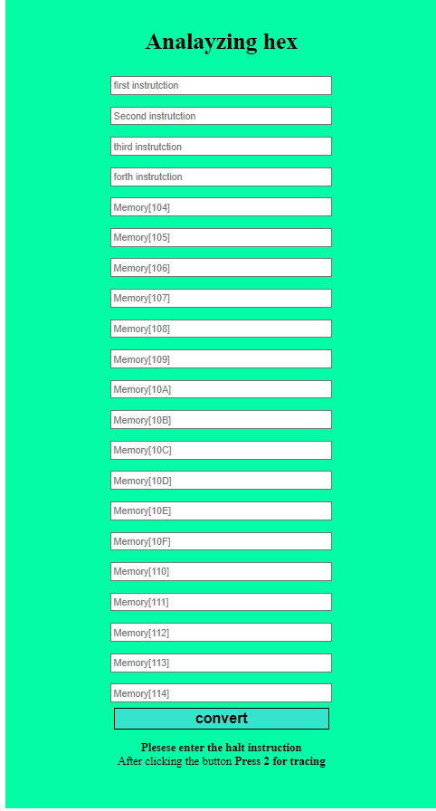Here we put all the four instruction and memory content

2-instruction analyzing phase

Here we get the instruction on binary for the hexadecimal IR and Instruction mnemonic

صورة تحتوي على نص, لقطة شاشة, شاشة عرض, لاعب

تم إنشاء الوصف تلقائياً

4-tracing phase

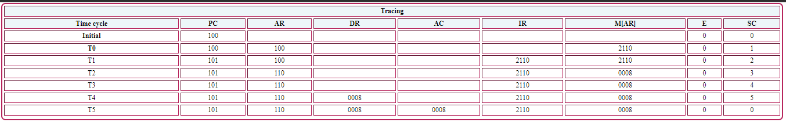Here we get the tracing of the instruction

## Testing

We tried out this value we start with getting it them from AC then we get the complement of AC Then increment AC then clear AC

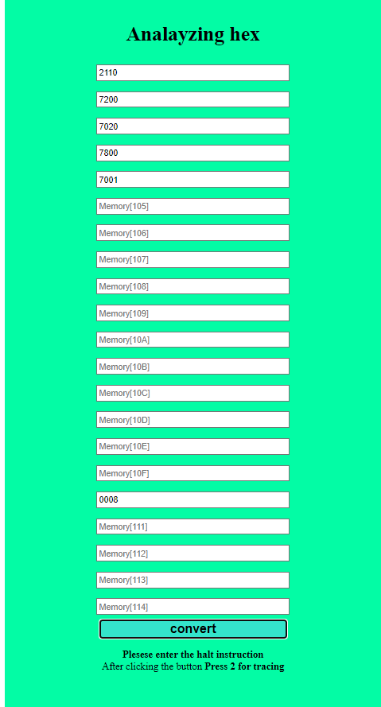

صورة تحتوي على نص, شاشة عرض, لقطة شاشة, معدني

تم إنشاء الوصف تلقائياًThese are the instruction analysis

صورة تحتوي على منضدة

تم إنشاء الوصف تلقائياًThese are the tracing part and it work prefectly

## Conclusion

To sum up, we get the goal of the project after the user input the instruction, the program will display the following data.

1- instruction mnemonic

2- tracing the instruction